Test cases for MP1

Test 1) Line of Text Terminated by a Newline

The client is able to connect to the server and the server gives the client a PID for forking. The server is able to echo what the client input on the port.

Test 2) Line of Text the Maximum Line Length Without a Newline

The maximum characters able to be sent without breaking up was at 80 characters.

Test 3) Line with No Characters and EOF

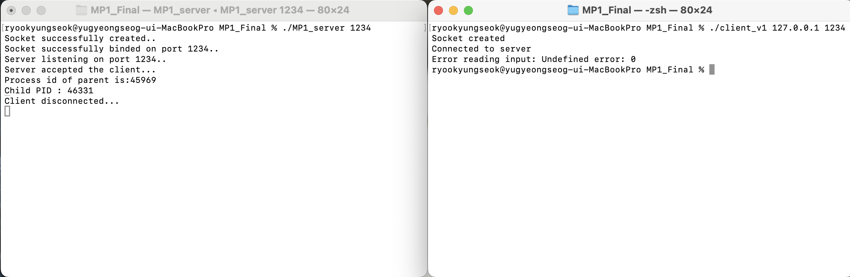  
The server disconects with the client after receiving an EOF (crtl-D)

Test 4) Client Terminated After Entering Text  
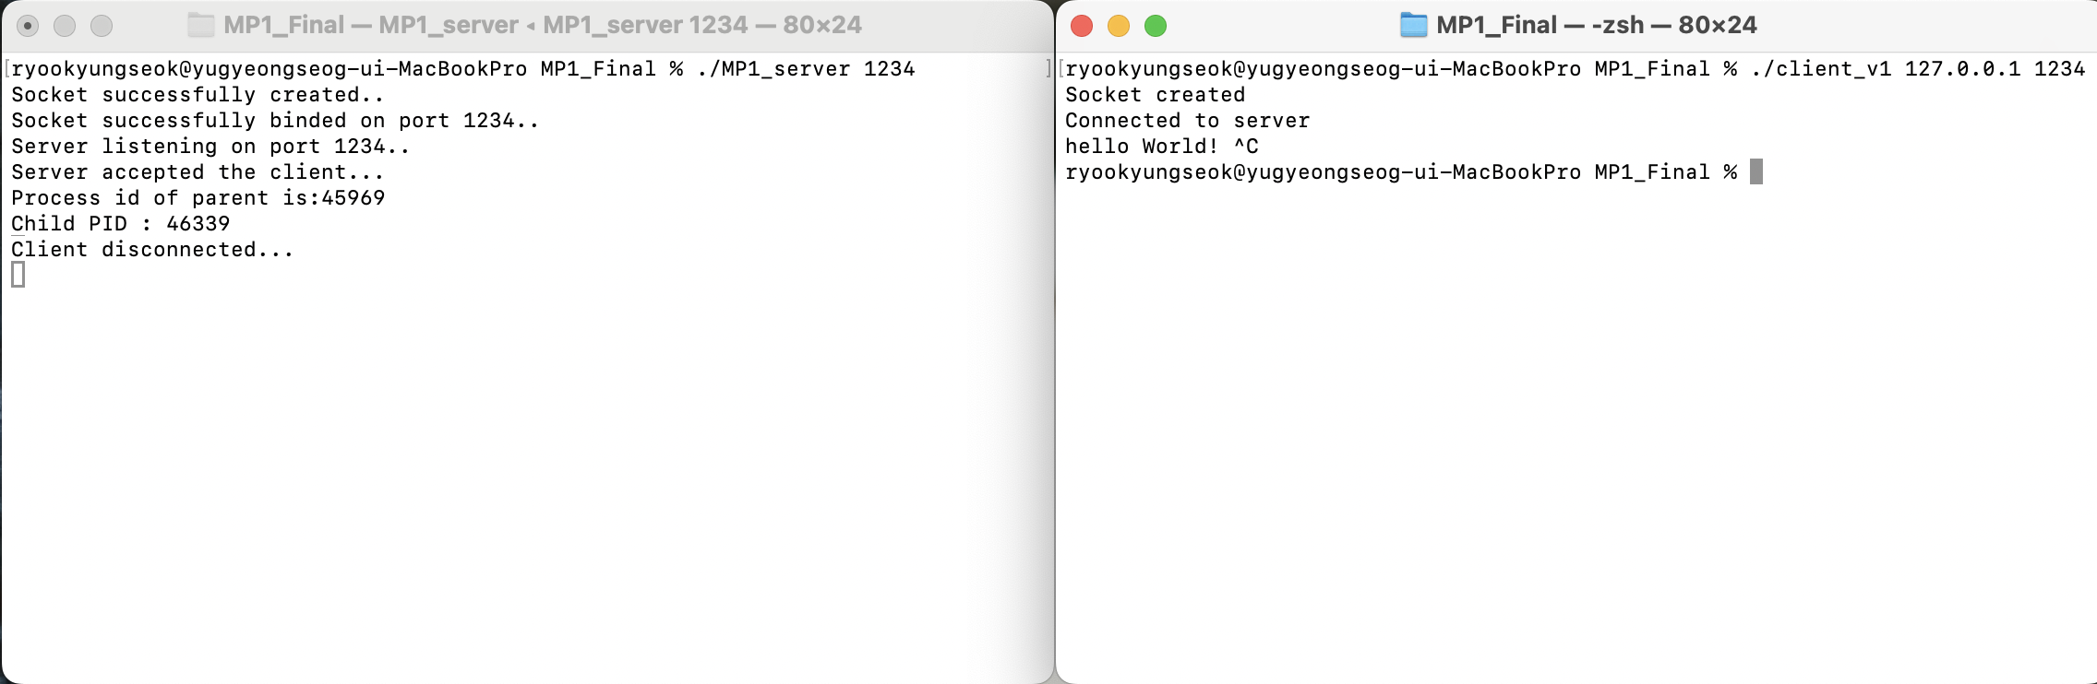

If the client is terminated after entering text, the text doesn’t go through to the server and results in a disconnection.

Test 5) Three Clients Connected to the Server

The server is able to accept 3 clients at once and can differanciate them with child PIDs

Test 6) Entering a newline character(enter key on keyboard) without any user input

The client disconnects when no text is sent and enter key is pressed.